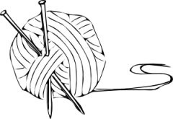

cran.r-project.org

johnmacfarlane.net/pandoc

Pandoc

www.rstudio.com

RStudio

ramnathv.github.io/slidify

www.libreoffice.org

tug.org/mactex

www.tug.org/texlive

miktex.org

yihui.name/knitr

github.com/cboettig/knitcitations